**VIT-AP UNIVERSITY, ANDHRA PRADESH**

**CSE3003 – Computer Networks - Lab Sheet: 9**

**Academic year:** 2023-2024  **Branch/ Class:** B.Tech

**Semester:** Fall  **Date: 5/04/24**

**Faculty Name:** Prof. S.Gopikrishnan  **School:** SCOPE

**Student name:Aman Sahu Reg. no.:22BCE7224**

**DNS, DHCP and FTP**

**Q1:**

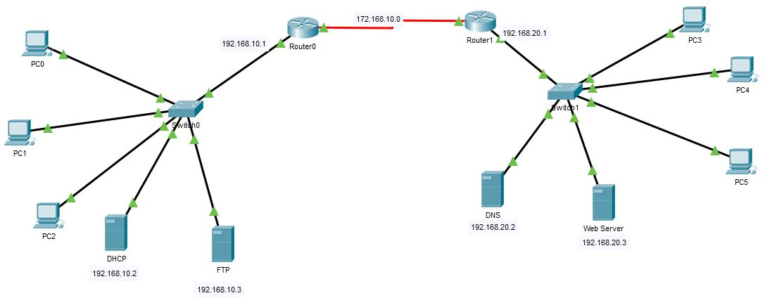

**Objectives:**

1. Design a network using two routers and switches with 3 - 4 PCs each and one DHCP, DNS, Web, and FTP server in the network.
2. Configure all the routers with any routing scheme.
3. Configure all the servers.
4. Verify the servers working.

**Verification and expected output:**

1. Website which is stored in HTTP Server should be accessible from any other PC
2. Txt file which is stored in FTP server should be accessible by any other PC
3. Screenshot of each successful Website verification and file is required.
4. IP Addressing table is also required.

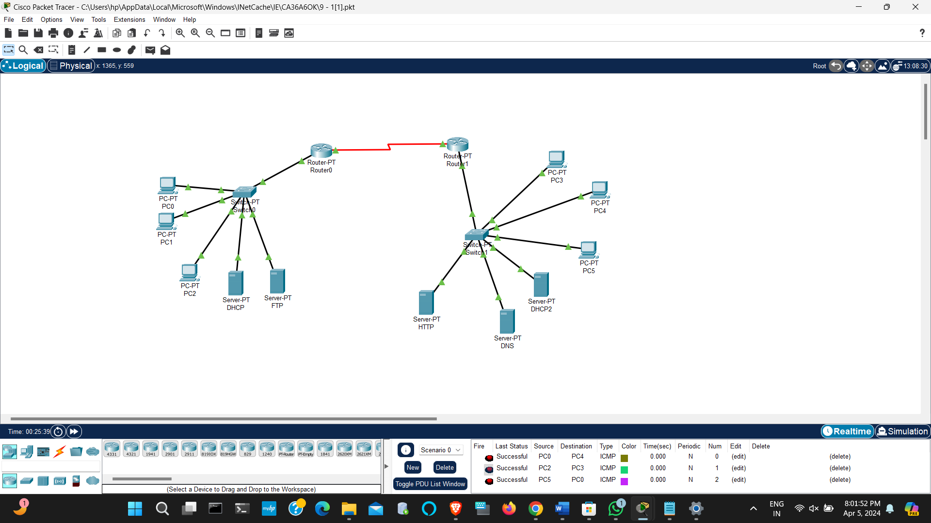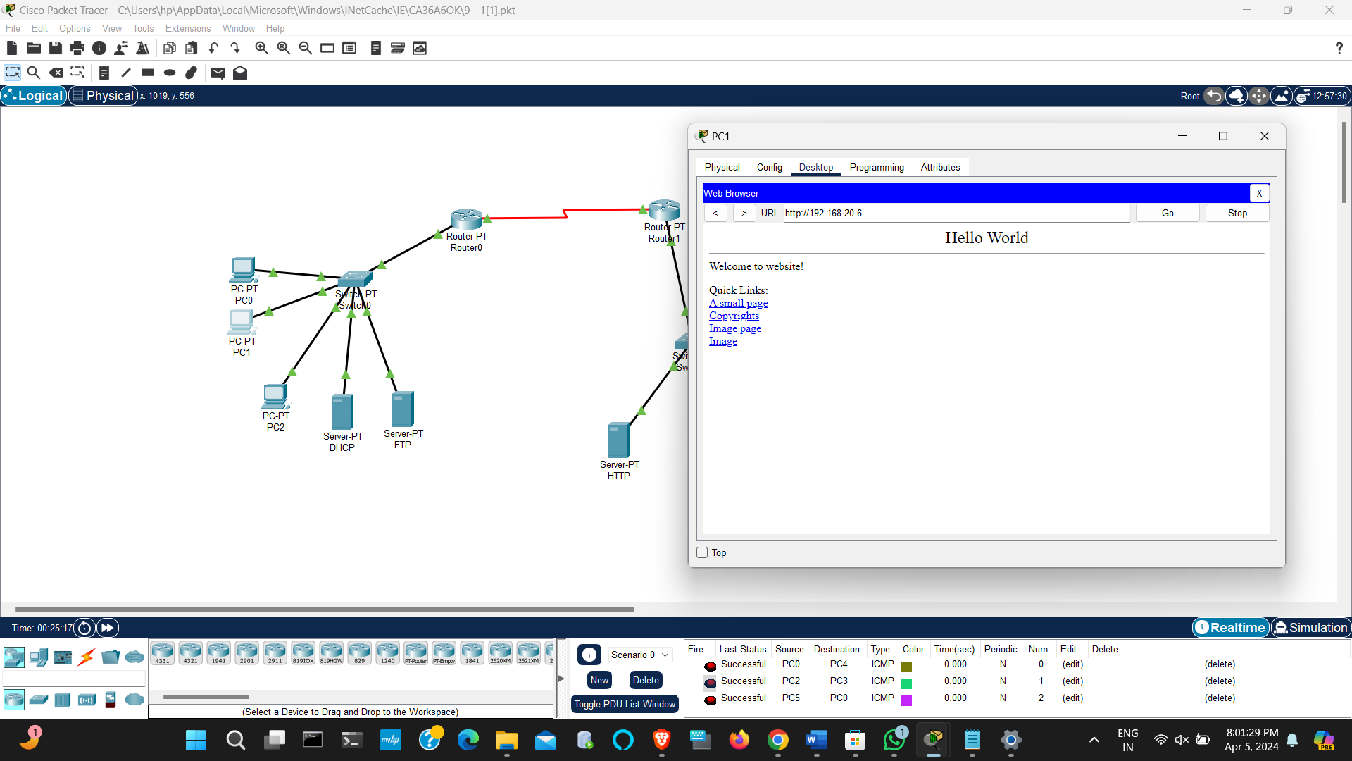

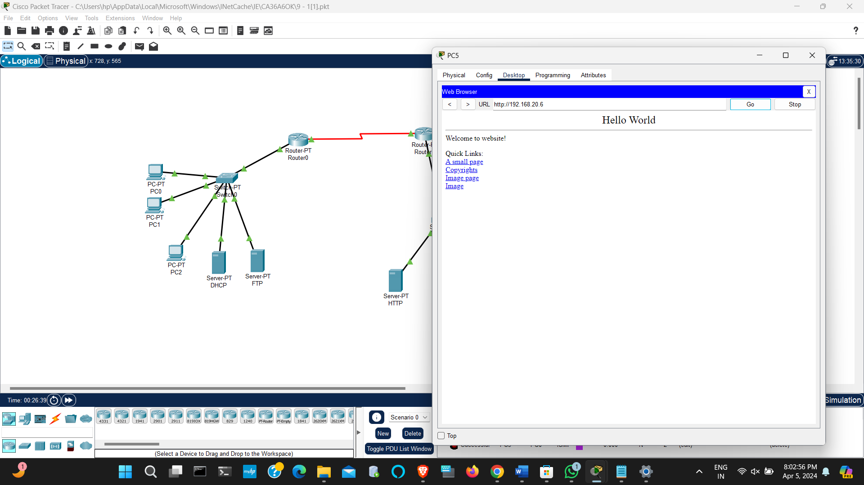

**ROUTING TABLE**

|  |  |  |
| --- | --- | --- |
| **DEVICE** | **IP ADDRESS** | **DNS SERVER** |
| **PC0** | **192.168.10.4** | **192.168.20.15** |
| **PC1** | **192.168.10.3** | **192.168.20.15** |
| **PC2** | **192.168.10.5** | **192.168.20.15** |
| **PC3** | **192.168.20.6** | **192.168.20.15** |
| **PC4** | **192.168.20.5** | **192.168.20.15** |
| **PC5** | **192.168.20.4** | **192.168.20.15** |
| **Router0** | **192.168.10.1/24** | **192.168.20.15** |
| **Router1** | **192.168.20.1/24** | **192.168.20.15** |
| **DNS Server** | **192.168.20.15** | **192.168.20.15** |
| **HTTP Server** | **192.168.20.3** | **192.168.20.15** |
| **DHCP Server** | **192.168.10.10** | **192.168.20.15** |
| **FTP Server** | **192.168.10.6** | **192.168.20.15** |

**Q2:**

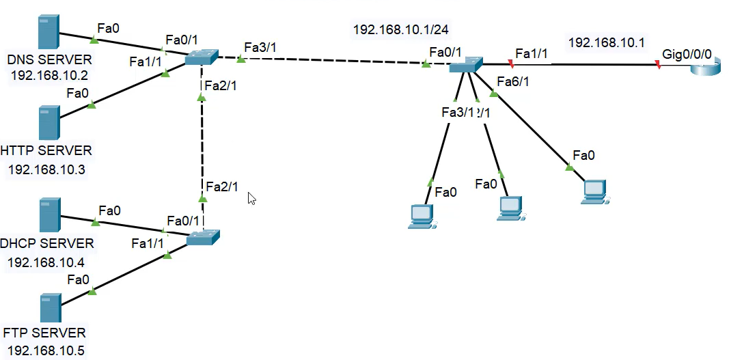

**Objectives:**

1. Design a network using two routers and switches with 3 - 4 PCs each and one DHCP, DNS, Web, and FTP server in the network.
2. Configure all the routers with any routing scheme.
3. Configure all the servers.
4. Verify the servers working.

**Verification and expected output:**

1. Website which is stored in HTTP Server should be accessible from any other PC
2. Txt file which is stored in FTP server should be accessible by any other PC
3. Screenshot of each successful Website verification and file is required.
4. IP Addressing table is also required.

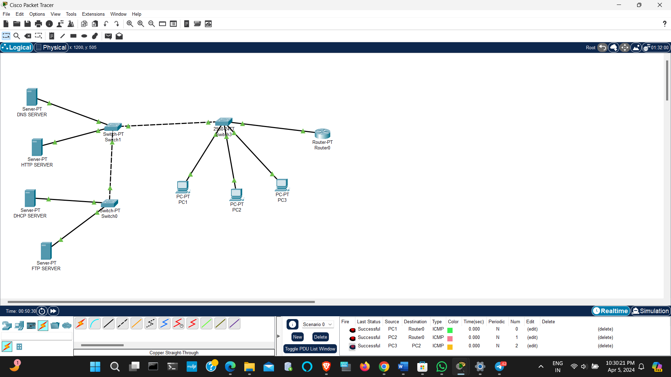 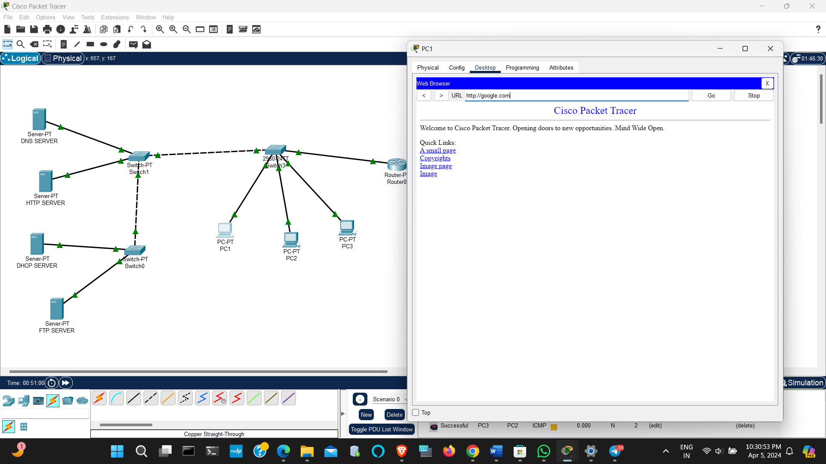

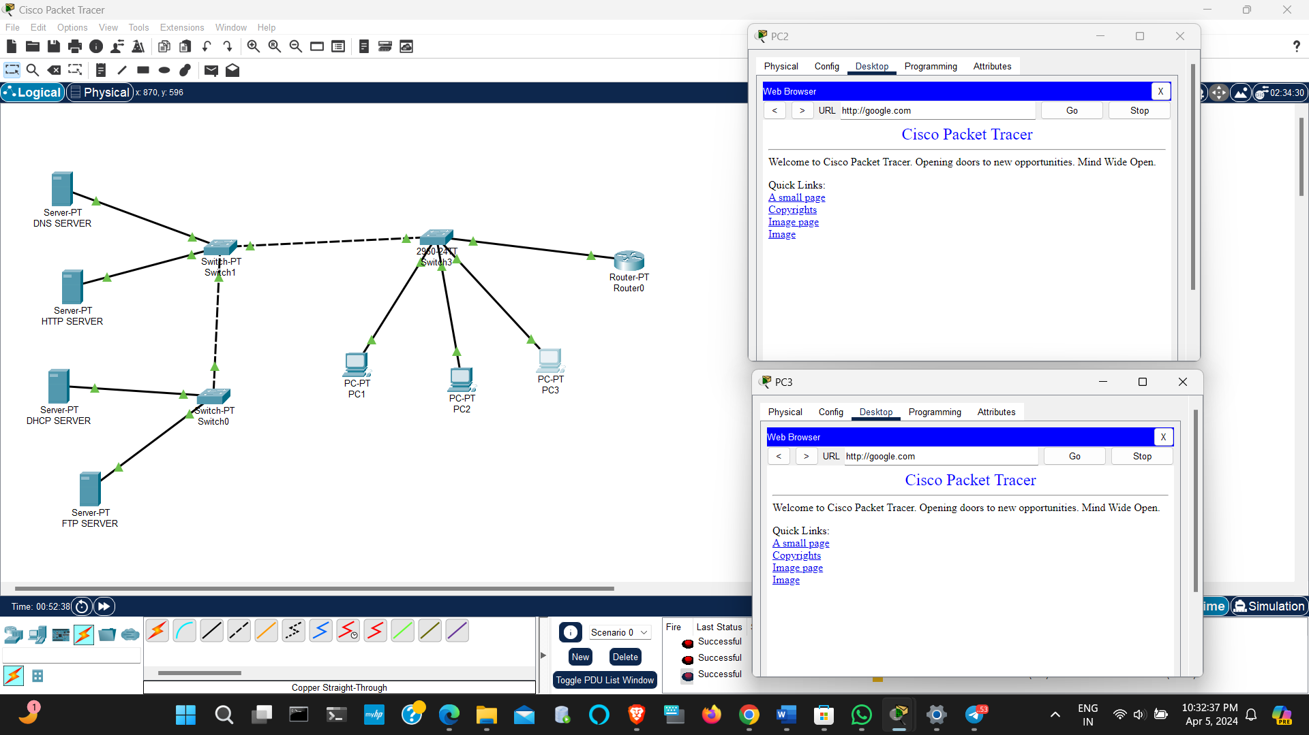

**ROUTING TABLE**

|  |  |  |
| --- | --- | --- |
| **DEVICE** | **IP ADDRESS** | **DNS SERVER** |
| **PC1** | **192.168.2.13** | **192.168.2.3** |
| **PC2** | **192.168.2.11** | **192.168.2.3** |
| **PC3** | **192.168.2.12** | **192.168.2.3** |
| **Router0** | **192.168.2.1/24** | **192.168.2.3** |
| **DNS Server** | **192.168.2.3** | **192.168.2.3** |
| **HTTP Server** | **192.168.2.4** | **192.168.2.3** |
| **DHCP Server** | **192.168.2.2** | **192.168.2.3** |
| **FTP Server** | **192.168.2.14** | **192.168.2.3** |